SERGEANT MAJOR PATRICK E. FAY
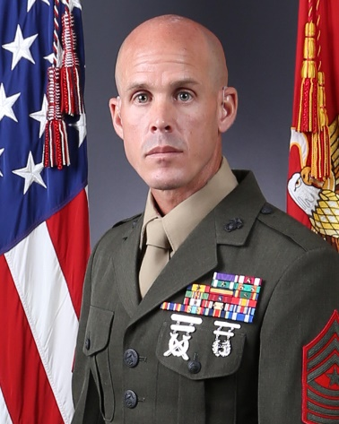
Sergeant Major Patrick E. Fay enlisted in the United States Marine Corps in January 1998 and graduated from 3d Recruit Training Battalion, Marine Corps Recruit Depot, San Diego, California in April 1998. Upon completion of recruit training, he attended infantry training at the School of Infantry, Camp Pendleton, California where upon completion, he received the military occupational specialty of 0341, Infantry Mortarman.

In July 1998, he received orders to Marine Barracks, Guantanamo Bay, Cuba, where he served as a 60mm mortar Assistant Gunner, Gunner, Section Leader, and Forward Observer with Rifle Security Company Leeward.

In July 1999, he was assigned to 3d Battalion, 5th Marines, Camp Pendleton, California. While there, he served as a Squad Leader, Section Leader, and Forward Observer with 81mm Mortar Platoon, Weapons Company. He was later re-assigned to Scout/Sniper Platoon, Headquarters and Service Company, where he served as an Assistant Team Leader and Team Leader. During this assignment, he participated in Operation Iraqi Freedom.

In October 2003, he received orders to 1st Marine Division Schools, Camp Pendleton, California. While there, he served as a Marine Corps Martial Arts Black Belt Instructor Trainer, Chief Instructor of the Marksmanship Training Unit, and Chief Instructor of the Pre-Scout/Sniper School.

In June 2006, he reported to 1st Battalion, 24th Marines, where he served on Inspector-Instructor duty as Chief Scout, Scout/Sniper Platoon, Headquarters and Service Company, as well as the Training Chief for Alpha Company. During this assignment, he participated in Operation Iraqi Freedom.

In August 2007, he received orders to Weapons and Field Training Battalion, Edson Range, Camp Pendleton, California where he served as the Line SNCO and Range SNCOIC aboard Delta Range.

In October 2008, he reported to Staff Noncommissioned Officer Academy, Camp Pendleton, California, where he served as a Faculty Advisor.

In October 2009, he received orders to 3d Battalion 1st Marines, Camp Pendleton, California, where he served as the Platoon Sergeant for Weapons Platoon, Company Gunnery Sergeant, and Company First Sergeant for Lima Company. During this assignment, he participated in Operation Enduring Freedom.

In September 2012, he reported to Staff Noncommissioned Officer Academy, Okinawa, Japan, where he served as a Faculty Advisor.

In April 2013, he reported to 7th Communication Battalion, Okinawa, Japan, where he served as the Company First Sergeant for Bravo Company, Service Company, and Headquarters Company.

In June 2015, he reported to Staff Noncommissioned Officer Academy, Marine Corps Base Hawaii, where he served as the Director.

In July 2018, Sergeant Major Fay reported to Marine Wing Support Squadron-272, Marine Corps Air Station New River, where he served as the Squadron Sergeant Major.

In January 2020, Sergeant Major Fay reported to 8th Engineer Support Battalion.

Sergeant Major Fay’s personal awards include the Purple Heart Medal, Meritorious Service Medal with two gold stars, Navy and Marine Corps Commendation Medal with gold star, Navy and Marine Corps Achievement Medal with two gold stars, and the Combat Action Ribbon with gold star.

