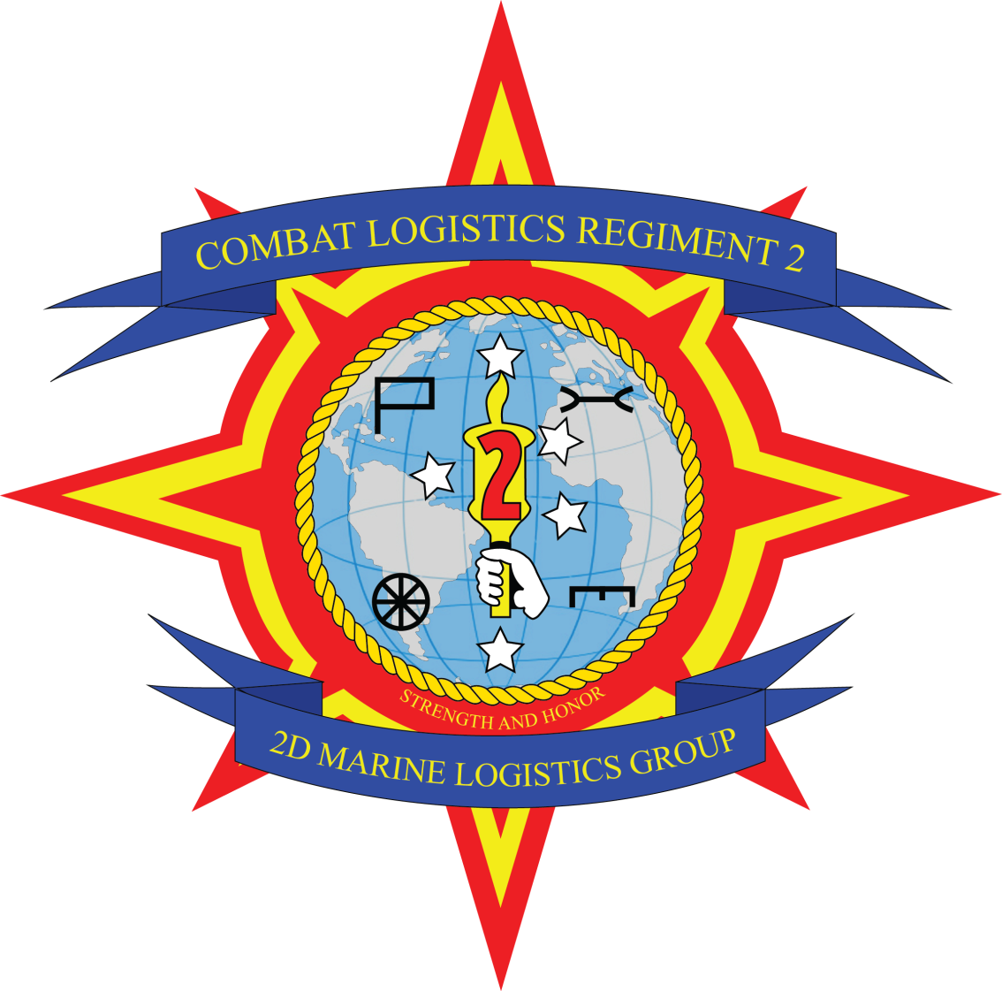

Welcome Aboard

**Combat Logistics Regiment 2**



**CLR 2 Leadership**

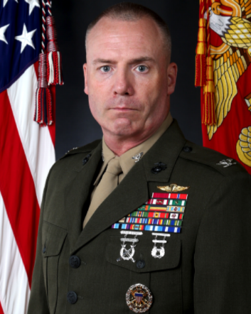 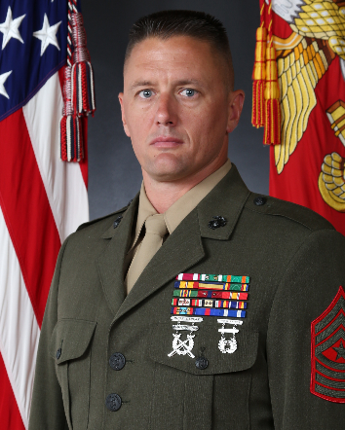

Col Michael E. McWilliams SgtMaj Clifford P. Fincham

**Welcome to CLR 2!**

This welcome aboard packet includes some common guidelines that should be followed by all members of Combat Logistics Regiment 2 (CLR 2). The Regiment wants to be sure you know the basics of what is expected of you before you begin your time at the unit.

It is your responsibility to report on time, in the proper uniform. (After working hours, during holidays, and weekends you will check-in with CLR 2 Regimental Officer of the Day (ROOD) (910) 450-7479 or (910) 467-2716. Be prepared to check in wearing the Service “A” uniform at 0730 the following business day.

You are expected to carry yourself, on and off duty, with the highest standards of the

Marine Corps and United States Navy, to include your time of transition from your previous command and throughout your tour at CLR 2.

If you are unsure or unable to complete what is required, ensure you contact your sponsor as soon as possible. SNCOs should make contact with the Regimental Sergeant Major as soon as official orders to CLR 2 are received; officers should contact the Regimental Executive Officer.

Located in this packet is information to help you and your family navigate your transition to your present assignment to CLR 2. If you encounter any issues please contact your sponsor immediately.

Please fill out the Welcome Aboard Questionnaire at the end of this package online or by e-mail to our S-1 (maria.razo@usmc.mil, and CC the First Sergeant (1stSgt McMillan: [joel.t.mcmillan@usmc.mil](mailto:joel.t.mcmillan@usmc.mil)) so we can learn more about you and your family.

**If your travel/arrival timeline changes, please notify your sponsor.**



**Message from the Commanding Officer**

***Welcome to Combat Logistics Regiment 2!*** We are truly glad that you will be serving with us. This is an outstanding, one-of-a-kind unit that performs an essential and unique mission in support of II Marine Expeditionary Force. Few Marine Corps organizations can boast the breadth and scope of influence of Combat Logistics Regiment 2 (CLR 2). I am humbled and honored to serve you as the Commanding Officer of this proud, distinguished, and critically vital unit.

Whether you’re single, engaged, or married with kids, this is a great place to serve! If this is your first duty station, I am confident that CLR 2 will positively shape the rest of your career. If this is one of many stops in your career, I hope this will be a unique experience and one of your best duty stations. The SgtMaj and I are happy to have you as a member of our team and look forward to serving with you. I am confident you will find your assignment to CLR 2 to be challenging and rewarding!

For the families: Families are a key and integral part of taking care of our people – our families are a critical component to our success! Marine Corps Family Team Building, Marine and Family Services, and numerous other organizations provide many services and resources for our families and us. In addition, outstanding programs such as: Military Family Life Counselors, L.I.N.K.S., New Parent Support, Military OneSource, Exceptional Family Member, Community Counseling Program and Semper Fit are but a few of the resources available to you and your family – please use them! The CLR 2 Deployment Readiness Coordinators, Mrs. Mary Mathews and Mr. Jeff Peters, are always available to answer your questions and to assist you and your family. Take advantage of their training and experience to enhance your family’s readiness. In their absence, anyone in your chain of command can and will help connect you and your family with the many resources available.

Throughout the year we have several family, single-Marine/Sailor, and all-hands events. Sometimes these events are meant to share information and provide training on available resources through Marine Corps Community Services (MCCS), other times the events are simply meant to be a way to meet other people within the Regiment, but we will always have fun!

Again, welcome to the Regiment. Always remember that defending our Nation is a humble honor bestowed upon but a few. This is an organization where your service will truly make a difference; I look forward to working together in the future.

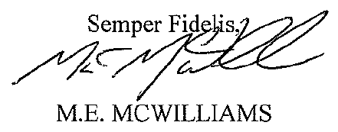



**Deployment Readiness Coordinators**

Welcome to the CLR 2 Family! Ms. Mary Mathews and Mr. Jeffrey Peters are proud to be the Deployment Readiness Coordinators (DRC) for Combat Logistics Regiment 2.

As a DRC, it is our responsibility to provide support for the Marine and their family members. The Marine Corps recognizes that Marines’ and Sailors’ support not only comes from a spouse, but from anyone the Marine deems as important to their well-being. This may include parents, siblings, and/or friends. One of our goals as a DRC is to ensure that you and your family receive the right type of information to allow you to take full advantage of your time in the Marine Corps and the Family Readiness Program. We encourage you to use us as a key resource for information and referral regarding any questions about programs or general life in the Marine Corps. Methods we will use to communicate with your family include sending out emails, website updates and our official Facebook.

Family members and Marines can contact the Deployment Readiness Coordinators for information, referral and deployment related issues--just to name a few. Additional support is also provided through Marine Corps Family Team Building, Marine and Family Programs, and the Base Chapel.

This booklet provides information on some of the services that may be beneficial to you while you are stationed aboard this installation. They include volunteer opportunities, base library services, Single Marine Program information, Military OneSource information, educational opportunities, and unit specific information.

Please call us with any issues that you may have concerning the resources available either on or off base, settling into a new area, deployment-related topics, or any other questions you may have. If you are unsure about anything, or would like more information, our door is always open!

Sincerely,

CLR 2 Deployment Readiness Coordinators

Mary Mathews & Jeffrey Peters

Office: (910) 450-6660 /451-0593

[mary.mathews@usmc.mil](mailto:mary.mathews@usmc.mil) / [Jeffrey.m.peters@usmc.mil](mailto:Jeffrey.m.peters@usmc.mil)

 “CLR 2 Family and Friends”



**Family Readiness**

It is the responsibility of every Marine to update his or her “Family Readiness Tab” information in MOL which is implemented to assist in providing information to Marines and those they designate. The unit’s Family Readiness Officer will send updated information regularly to keep you “in the know” with announcements, photos, forums, surveys, and family readiness resources. The sole purpose is to effectively communicate family readiness information and notifications to Marines, their family members and friends that are registered by your Marine as designated contacts.

When updating the Family Readiness Tab in MOL, please ensure you have a minimum of one contact, but may have up to five. Married Marines must list their spouse as one of their contacts, or see the FRO to provide an “opt-out” form.

**Camp Lejeune Welcome Aboard Brief**

Location: Bldg. 59 Rm. 204 (Upstairs in Joint Reception Center)

Time: 0830-1100

Monday – Friday

**Spouses are Encouraged to Attend!**

Attendees must be at **Joint Reception Center** (**JRC) NLT 0815 as the brief begins promptly at 0830.** Marine must be in the uniform of the day (no flight suits) and you need to bring a pen or pencil.

For more information, contact the JRC at (910) 451-7796



**CLR 2 HQ, BEQ, and Mess Hall LOCATIONS**

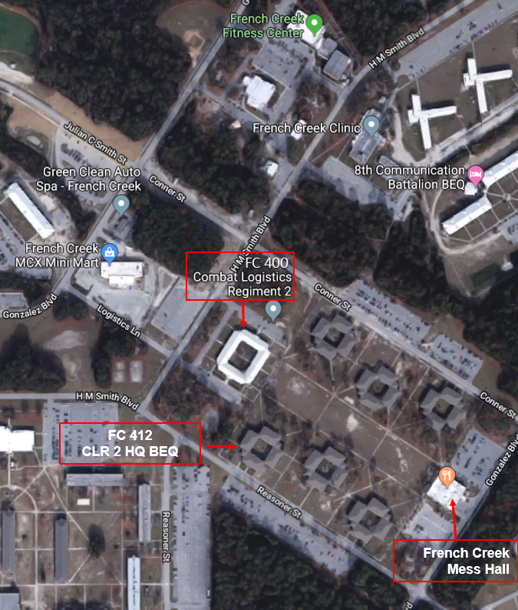

BEQ Manager: 910-450-8275

CLR 2 MAILING ADDRESS:

COMBAT LOGISTICS REGIMENT 2

2D MARINE LOGISTICS GROUP

PSC BOX 20132

CAMP LEJEUNE NC 28542-0132







**Camp Lejeune Map**

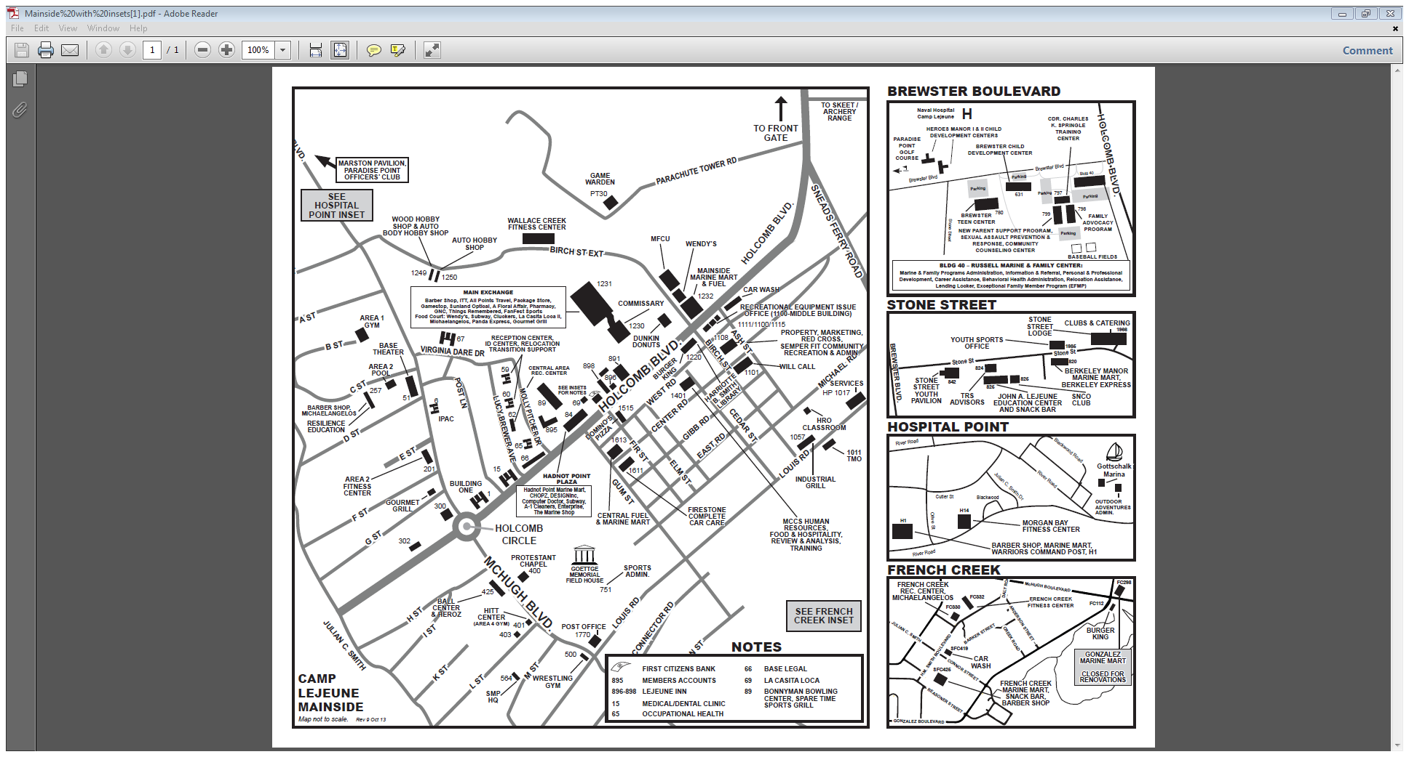



**Regiment Points of Contact**

**Regiment Duty Officer (24/7): (910) 450-7479**

**Regimental Duty Officer Cell: (910) 467-2716**

Executive Officer (910) 450-8682

Sergeant Major (910) 450-8684

Barracks Manager (910) 450-8275

Family Readiness Officer (910) 450-6660

Camp Lejeune Vehicle Registration Office (910) 451-7735

Chaplain (910) 451-9800

Headquarters Company Commander (910) 450-7531

Headquarters Company 1st Sergeant (910) 450-7482

Headquarters Company Gunnery Sergeant (910) 450-6802

Military and Family Life Counselor (910) 988-9700



**Camp Lejeune Temporary Lodging**

These convenient lodging and hospitality options are open 24 hours a day, 7 days a week. They strive to lead hospitality services in the military community through efficient management and quality of operations. Each facility operates independently of MCCS, so please contact them with any specific questions or concerns about your stay.

**Inns of the Corps**

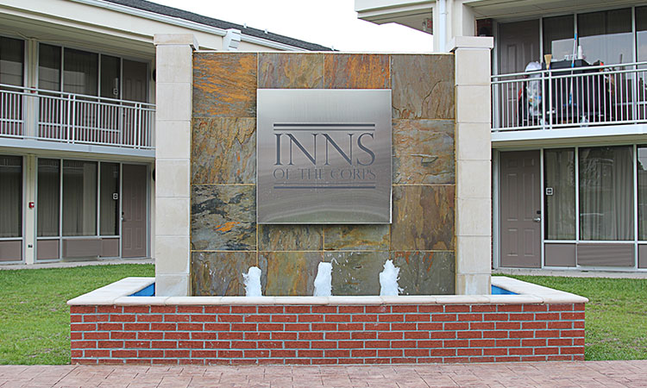

**Inns of the Corps** features rooms with king or queen-size beds. Complimentary WiFi is available in all rooms, and throughout the building’s common areas. Free continental breakfast, guest laundry, playgrounds, ice and vending machines, lounges, a fenced-in dog park and access to the Wallace Creek Fitness Center are just some of the amenities available to guests.

**Located** on Holcomb Blvd, Camp Lejeune, NC 28547

**Website:** [innsofthecorps.com](http://mccscherrypoint.com/shopping-services/lodging)

**Front Desk Open 24/7**

**(910) 451-3041**

Rates:

ADA Family Suite $125/night

Family Suite $125/night

ADA King $91/night

Executive Double Queen (pet friendly) $91/night

Executive Double Queen $91/night

**Due to very high demands, reservations can be made as follows:**

PCS: reservations may be made (1) year in advance

TAD/TDY: reservations may be made (90) days in advance

Leisure Travel: reservations may be made (60) days prior to arrival date



**MCB Camp Lejeune Temporary Lodging (Continued)**

**Onslow Beach**

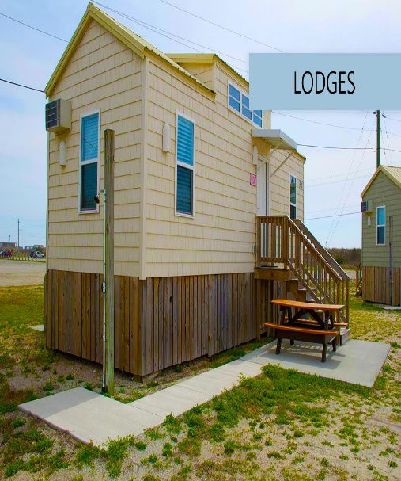 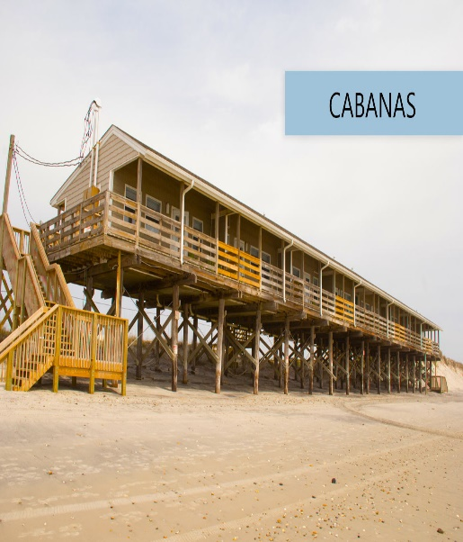

**Onslow Beach** offers lodges, cabanas, “ospreys” and various other lodging options, including an RV park and a camp ground. Located on the beach, your pets are welcome and there are places for you to shop, swim and enjoy time with your family!

**Located on BA-275 Beach Road, Camp Lejeune, NC 28547**

**Reservation Line:** (910) 440-7502

**Rates are dependent on length and time of stay and preferred lodging choice.**

**Visit** [**http://www.mccslejeune-newriver.com/beach/#res**](http://www.mccslejeune-newriver.com/beach/#res) **for more information regarding a stay at Onslow Beach.**



**Housing**

* **Atlantic Marine Corps Communities Housing Office**
  + **Hours:** Monday – Friday: 8:00 A.M – 5:00 P.M.

Saturday: Appointment Only

* + **Office Phone:** (888) 690-4304
  + **Website:** <https://www.atlanticmcc.com/>
  + **Location:** Camp Lejeune Leasing Center, 43 Inchon Street, Tarawa Terrace, NC, 28543
* **Lincoln Military Housing** 
  + **Hours:** Monday – Friday 8:00 A.M – 5:00 P.M.

Saturday: Appointment Only

* + **Office Phone:** (910) 353-2460
  + **Website:**  <https://lincolnmilitary.com/>
  + **Location:** Camp Lejeune Leasing Center, 43 Inchon Street, Tarawa Terrace, NC, 28543
* **Most individuals stationed at MCB Camp Lejeune who choose to live off base, live in the following areas.** 
  + - Richlands: Average drive time = 30 mins
    - New River: Average drive time = 21 mins
    - Topsail: Average drive time = 40 mins
    - Sneads Ferry: Average drive time = 20 mins
    - Hubert: Average drive time = 15-25 mins
    - Emerald Isle/Cedar Point: Average drive time = 40 - 45 mins
    - Swansboro: Average drive time = 30 - 40 mins

***NOTE: The significant range in drive time accounts for the large area that these towns/cities cover.***



**Local Schools**

**School Liaison Program**  
Bldg. 780, Brewster Blvd., Camp Lejeune, NC 28547   
(910) 449-9915

**Monday – Friday 7:00 A.M. – 4:00 P.M.**

The school liaison officers are available to help with ALL K-12 education issues for public, private, DoDEA and homeschooled students for all branches of the military at any local installation. Contact the School Liaison Office to discuss assistance with changing and finding schools in the area, transitions, deployments, moving tips and school advice. You can also get resources for tutoring, scholarships and SAT/ACT prep.

*We also have information on local Homeschooling Groups!*

**Camp Lejeune* District School**

**(Includes: New River, Pender and Jones County, Homeschool)**

(910) 449-9915

(910) 382-5639

**Onslow County Schools**

**(Includes: Duplin and Lenior County, Private and Charter schools)**

(910) 449-9749

(910) 358-3926

**Cateret, Craven, and Pamlico County Schools**

(252) 466-4678

**\*Students must live on base to attend school aboard MCB Camp Lejeune**



**MCCS Directory**

**DINING**

|  |  |
| --- | --- |
|  |  |
| Berkeley Express | (910) 451-9073 |
| CHOPZ | (910) 451-3896 |
| Domino’s | (910) 451-3888 |
| Dunkin’ Donuts/Baskin Robbins | (910) 451-2599 |
| Duffers’ Retreat | (910) 451-0148 |
| HEROZ Sports Grill | (910) 450-6428 |
| Industrial Grill | (910) 451-8680 |
| Jimmy John’s | (910) 449-8850 |
| La Casita Loca | (910) 450-9606 |
| Papa John’s | (910) 450-7272 |
| Spare Time Sports Grill | (910) 451-5731 |
| Subway | (910) 450-9295 |
| Starbucks | (910) 450-2825 |
| Taco Bell | (910) 450-6918 |
| University Café | (910) 450-9567 |
| Warrior’s Command Post | (910) 451-8822 |
| Wendy’s | (910) 451-5479 |

**FAMILY TEAM BUILDING**

|  |  |
| --- | --- |
| Family Readiness Training | (910) 451-0176 |
| LINKS | (910) 450-1465 |

**MARINE & FAMILY PROGRAMS**

|  |  |
| --- | --- |
| Child Development Center (Including hourly rates) | (910) 450-0553/0554/0555 |
| Counseling – Personal and Marital - appointments | (910) 451-2864 |
| Family Member Employment Assistance | (910) 450-1676 |
| Exceptional Family Member Assistance | (910) 451-4394 |
| Family Advocacy | (910) 449-6110 |
| Financial Management – Accounting Supervisor | (910) 449-5612 |
| FOCUS (Families Overcoming Under Stress) | (910) 450-5635 |
| Library | (910) 449-6715 |
| New Parent Support | (910) 449-4866 |
| Relocation Assistance | (910) 451-1055 |
| Substance Abuse Counseling | (910) 451-2865 |
| Transition Assistance | (910) 451-3781/451-3754 |
|  | (910) 376-2155 |



**MCCS Directory (Continued)**

**EDUCATION**

|  |  |
| --- | --- |
| Education Center | (910) 451-3091 |
| Financial Assistance | (910) 449-6623 |

**COLLEGES & UNIVERSITIES**

|  |  |
| --- | --- |
|  |  |
| Campbell University | (910) 451-3097 |
| Coastal Carolina Community College | (910) 455-1221 |
| Southern Illinois University – Carbondale | (618) 453-3430 |
| University of North Carolina – Wilmington | (910) 455-2310 |
| Webster University | (910) 451-4407 |

**RECREATIONAL FUN**

|  |  |
| --- | --- |
|  |  |
| Bonnyman Bowling Center | (910) 451-5121 |
| Camp Lejeune Base Theater | (910) 451-2785 |
| Gottschalk Marina | (910) 451-8307 |
| McIntyre-Parks Recreational Shooting Complex | (910) 451-3889 |
| Midway Park Theater | (910) 451-2785 |
| Onslow RV Park & Campground | (910) 440-7502 |
| Outdoor Adventures | (910) 451-1440 |
| Paradise Point Golf Course | (910) 451-5445 |
| Pistol Range | (910) 451-3889 |
| Tarawa Terrace Community Center | (910) 450-1687 |

**RETAIL/SERVICES**

|  |  |  |
| --- | --- | --- |
|  |  | |
| A Floral Affair | | (910) 451-2674 |
| American Clipper Barber Shop (near MCX) | | (910) 451-2400 |
| Auto Skills Center | | (910) 451-1550 |
| DESIGNinc | | (910) 451-3209 |
| Enterprise | | (910) 451-7744 |
| Firestone Complete Auto Care | | (910) 915-8111 |
| Gadget Geeks | | (910) 376-8386 |
| GameStop | | (910) 450-9951 |
| GNC | | (910) 451-4845 |
| H&R Block | | (910) 450-5967/5968 |
| Lane Optometry, PLLC | | (910) 451-3937 |



**MCCS Directory (Cont.)**

|  |  |
| --- | --- |
| RETAIL/SERVICES contd. |  |
| A Floral Affair | (910) 451-2674 |
| American Clipper Barber Shop (near MCX) | (910) 451-2400 |
| Auto Skills Center | (910) 451-1550 |
| Firestone Complete Auto Care | (910) 910-8111 |
| Gadget Geeks | (910) 376-8386 |
| GNC | (910) 451-4845 |
| Lejeune Harley-Davidson | (910) 353-9997 |
| MCX Main Exchange | (910) 451-5030 |
| DESIGNinc | (910) 451-3209 |
| Military Clothing Sales and Services | (910) 451-2802 |
| Enterprise | (910) 451-7744 |
| GameStop | (910) 450-9951 |
| Model Cleaners | (910) 451-5685 |
| H&R Block | (910) 450-5967/5968 |
| NAPA Auto Parts | (910) 787-9506 |
| NHCL Branch Pharmacy | (910) 451-0852/3554/0331 |
| Things Remembered | (910) 451-6619 |
| Tun Alley Wines, Spirits & More | (910) 451-1430 |



**SEMPER FIT**

|  |  |
| --- | --- |
|  |  |
| Area 2 Gym | (910) 451-8209 |
| Aquatics Office | (910) 449-4309 |
| French Creek Fitness Center | (910) 451-3584 |
| HITT Center | (910) 451-0122 |
| Wallace Creek Fitness Center (has Indoor Pool) | (910) 450-7652 |

**CLUBS**

|  |  |
| --- | --- |
|  |  |
| Paradise Point O-Club | (910) 451-2465 |
| SNCO Club | (910) 450-9556 |

**Visit the MCCS website:** [**www.mccslejeune-newriver.com**](http://www.mccslejeune-newriver.com)



**Camp Lejeune Liberty Boundaries**

**85 Miles = Daily **

**250 Miles = Weekend Liberty **

**350 Miles = 72 Hour Liberty **

**450 Miles = 96 Hour Liberty**

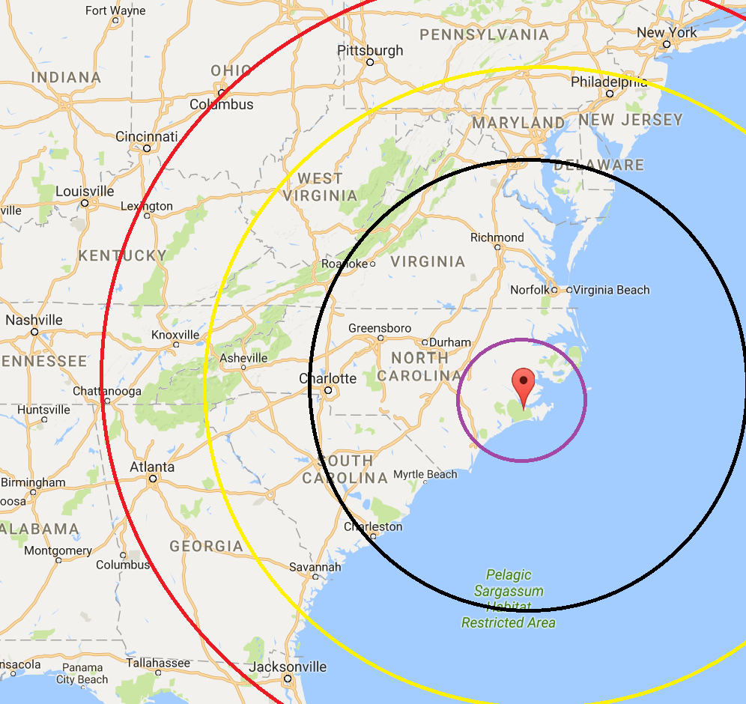



|  |  |
| --- | --- |
| **New Bern** | <http://www.visitnewbern.com/> |
|  |  |
| **Craven County Government** | <http://www.cravencountync.gov/> |
|  |  |
| **Jacksonville-Onslow Chamber of Commerce** | [http://www.jacksonvilleonline.org](http://www.jacksonvilleonline.org/) |
|  |  |
| **Beaufort Historic Site** | [http://www.beauforthistoricsite.org](http://www.beauforthistoricsite.org/) |
|  |  |
| **Tryon Palace Sites & Gardens** | <http://www.tryonpalace.org> |
|  |  |
| **Busch Gardens** | <https://buschgardens.com/> |
|  |  |
| **North Carolina Aquariums** | [http://www.ncaquariums.com](http://www.ncaquariums.com/) |
|  |  |
| **Outer Banks** | [http://www.outerbanks.org](http://www.outerbanks.org/) |
|  |  |
| **Cape Lookout National Seashore** | <http://www.nps.gov/calo/> |
|  |  |
| **Shackleford Horses** | [http://www.shacklefordhorses.org](http://www.shacklefordhorses.org/) |
|  |  |
| **Wilmington NC & Cape Fear Coast** | <http://www.wilmingtonandbeaches.com/> |
|  |  |
| **Fayetteville** | [http://www.visitfayettevillenc.com](http://www.visitfayettevillenc.com/) |
|  |  |
| **Raleigh** | [http://www.visitraleigh.com](http://www.visitraleigh.com/) |
|  |  |
| **NCCOAST** | [http://nccoast.com](http://nccoast.com/) |
|  |  |
| **Myrtle Beach, SC** | <http://www.visitmyrtlebeach.com/?cid=g_destination_mb> |
|  |  |
| **Visit North Carolina** | [http://www.visitnc.com](http://www.visitnc.com/) |
|  |  |
| **Historic Williamsburg, Virginia** | <http://www.williamsburgva.gov/> |

**Useful Websites**



**Off-Limits Establishments (MCIEAST-MCB CAMLEJEUNEBul 1620)**

|  |  |
| --- | --- |
|  |  |
|  |  |

Atheas Attic; 420 Eastwood Rd, Wilmington, NC

Bell Auto Salvage II; 136 Abbits Branch Rd, Hubert, NC

Club Phoenix; 209 East 5th Street, Greenville, NC

Dash-In; 1316 Hargett St, Jacksonville, NC

D’s Drive Thru (A.K.A. Raul’s Drive Thru); 226 Wilmington Hwy, Jacksonville, NC

D’s Quick Mart; 2840 Hwy 258 West, Richlands, NC

Expressions; 419 South College Rd #39, Wilmington, NC

Express Way; 1261 Gum Branch Rd, Jacksonville, NC

Flyers, 400 Fontana Blvd, Havelock, NC 28532

Golden Dragon (A.K.A Tokyo Asian House); 1850 Wilmington Hwy, Jacksonville, NC

Karen Huffman’s Cleaning, Jacksonville, NC

King’s Tobacco Drive Thru (Next to Ronnie’s Classic Auto Sales); 1796 Gum Branch Rd, Jacksonville, NC

Laird’s Auto and Truck Repair (U-Haul Rental); 1197 Piney Green Rd, Jacksonville, NC

MP Super Discount; 800 Shipyard Blvd, Wilmington, NC

One Stop Shop; 501 Corbin St, Jacksonville, NC

Price is Right Lawn Design; Jacksonville, NC

Saint Thomas Custom Homes, 3560 McArthur Road, Broadway NC

Smart Buy, 375 Jacksonville Mall, Jacksonville, NC (currently not open, but has history of reappearing)

Tasty II/Taco’s Best, 2119 Lejeune Boulevard, Jacksonville, NC

Tobacco; 521 Yopp Rd, Unit 106, Jacksonville, NC

Tobacco Leaf; 343K Western Blvd, Jacksonville, NC

Veterans Affairs Services; (A Private Organization, not affiliated with the Department of Veterans Affairs (VA) of the VA Outpatient Clinic) Jacksonville, NC



**Off-Limits Roads**

* Catfish Lake Road (Rt 1100): Per MEF Order 5100.3: "Catfish Lake Road may only be traveled when a Marine or Sailor has a legitimate reason for being on the unpaved portions of the road, e.g., hunting, fishing, or engaging in other lawful recreational activities."
* 9 Mile Road: Off limits to government and tactical vehicles
* 9 Foot Road: Off limits to government and tactical vehicles

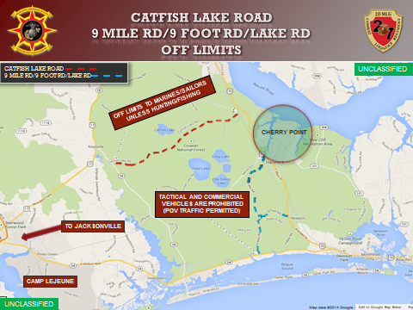

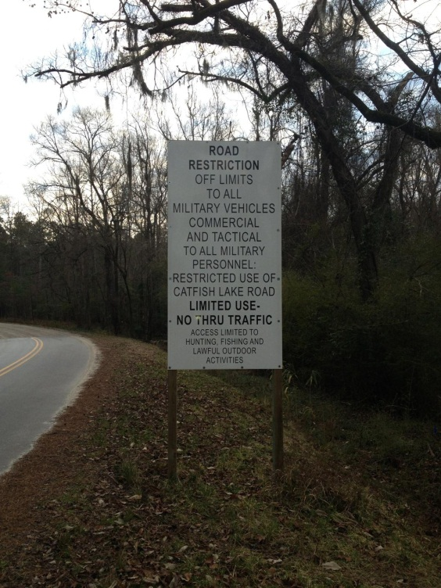

**Local Volunteer Opportunities**



There are so many ways to get involved in the community that you are now a part of! Each week there is an “All Hands” email sent to every Marine and Sailor’s .mil address with a list of current opportunities where volunteers are needed! People volunteer for a wide variety of reasons, especially wanting to help others. However, volunteering is also a way to help yourself!

Some people are uncomfortable with the notion that a volunteer “benefits” from doing volunteer work. The best volunteering does involve the desire to serve others, but this does not exclude other motivations. Instead of considering volunteering as something you do for people who are not as fortunate as yourself, begin to think of it as an exchange.

Consider that most people find themselves in need at some point in their lives. So today you may be the person with the ability to help, but tomorrow you may be the recipient of someone else’s volunteer effort Adding your effort to the work of others makes everyone’s lives better.

**Local Agencies that rely on volunteers.**

• Single Marine Programs—(910) 449-5145

• Navy Marine Corps Relief Society —(910) 451-5346

• School Liaison Program (includes local schools)—(910) 449-9915/9749

• Habitat for Humanity Restore — (910) 347-9400

• Habitat for Humanity—Carteret County—(252) 726-1399

• Youth Sports—(910) 451-2177/2159

• Marine Corps Family Team Building—(910) 451-0176

• Local Fire Departments—(910) 455-8080

• Humane Society—(252) 247-7744

• Boys & Girls Club—(910) 455-9003

• Jacksonville Commons Complex—(910) 938-5312

* Adoption First Animal Rescue—www.adoptionfirstanimalrescue.com

**For individuals interested in volunteering to assist with CLR 2 events, please contact our unit Deployment Readiness Coordinators, Mrs. Mary Mathews or Mr. Jeff Petters**

Keep in mind that volunteers **must** be volunteers (Nobody can, or should, tell you to participate. While service members from the same unit may personally decide to participate together, no one in the unit's chain of command may direct such participation.) Volunteers must be on authorized liberty (Involvement in this activity needs to be on your personal time; not when you are in an official duty status. Similarly, military uniforms, and government materials and equipment intended for official use only, may not be used during your involvement in such events.)



**Camp Lejeune Resources**

**Libraries**

**Harriotte B. Smith Library**

* **Library Hours of Operation:** Monday- Friday 08:00 A.M – 7:00 P.M.

Saturday and Sunday10:00 A.M. – 6:00 P.M.

**John A. Lejeune Education Center Research Library**

* **Library Hours of Operation:** Monday- Thursday 10:00 A.M. – 7:00 P.M.

**Recreational Equipment Rental**

**Bldg. 1100, West Road (between Ash & Birch St.) Camp Lejeune**

**(910) 451-1368**

***Why buy when you can rent?***

* **Party items:** Bounce Houses,tables, chairs, canopies, ice chest, pig cookers, and much more.
* **Camping equipment:** Campers,tent, fishing pole, stove, mini grill, heater, canoe/kayak, and much more
* **Lawn, home & garden equipment:** dolly, extension cord, ladder, hedge clipper, lawn mower, generator, and much more.
* For a complete list visit <http://www.mccslejeune-newriver.com/recissue/REIS-Catalog-031617/index.html>

**Auto Skills Center**

Auto Skilz Center

1250 Birch St. Extension, Camp Lejeune

(910) 451-1550

Offers state-of-the-art equipment such as scanners for on-board computer diagnostics (check engine light), vehicle lifts, hand tools & a Master ASE Certified Technician on site & much more!

* Hours: Wednesday – Friday 10:30 A.M. – 7:00 P.M.

Saturday – Sunday 09:00 A.M. – 5:00 P.M.

* Clean up begins 45 minutes prior to closing.
* For more information or prices call (**910) 451-1550** orvisit <http://www.mccslejeune-newriver.com/autocenter/>



**Resources Continued**

**Firestone Complete Auto Care**

West Road, Bldg. 1611, Camp Lejeune

(910) 915-8111

Offers full service auto-care center offering a wide variety of auto repairs. Firestone Complete Auto Care also sells trusted, name-brand tires to keep your vehicle rolling smoothly. ASE-certified technicians meet all your advanced diagnostic and repair needs, and oil-change and tire specialists are available at all times for general maintenance. We’ll keep your vehicle in top operating condition year-round, and we can perform your NC state safety inspection at any time of the year.

* Hours: Monday – Friday 07:00 A.M. – 7:00 P.M.

Saturday 07:00 A.M. – 6:00 P.M.

Sunday 08:00 A.M. – 5:00 P.M.

* For more information or prices call (**910) 915-8111** orvisit the below website at  
  <https://local.firestonecompleteautocare.com/north-carolina/camp-lejeune/building-1611-west-rd/>
* Services include, but not limited to:
  + 4 Wheel Alignments
  + A/C Service
  + Battery Install
  + Brakes
  + Check Engine Lights
  + Cooling System
  + Drive Train Differential & Axle
  + Electrical Check
  + Electronic Systems Diagnosis
  + Fuel System
  + Oil Changes
  + Scheduled Maintenance
  + Starting & Charging Systems
  + State Inspections
  + Suspension & Steering Repair
  + Timing Belts
  + Tires
  + Transmission Service
  + Tune Ups



**Resources Continued**

**Health Resources**

Emergency Room (910) 450-3392

Information (910) 450-3392

Quarterdeck (910) 451-3079

Appointment Line (910) 450-HELP (4357)

TRICARE (Humana) (800) 444-5445

Refill Line (866) 207-1028

***Sign up online today for Relay Health. This is a great tool to be able to communicate with your PCM.***

**http://www.med.navy.mil/sites/cpoint/Patients/Pages/MedicalHome.aspx**

**Other Resources**

Child Care Registration Resource and Referral (910) 450-0553/0554/0555

Children, Youth and Teen Program (910) 450-0553/0554/0555

Youth Sports (910) 451-2177

Marine & Family Services (910) 451-1056

Navy-Marine Corps Relief Society (910) 451-5346

Legal Office (M-F 0730-1630; POA’s/Wills 0945) (910) 451-1903/7085

PMO (910) 451-4688 Current Weather Advisory (910) 451-1717

**Education Info**

Education Info

**John A. Lejeune Education Center**

Bldg. 825 Stone St., Camp Lejeune

(910) 451-3091

Did you know that some of your MCIs and Marine Corps Training can transfer into college credits?

Local Colleges:

* Coastal Carolina Community College (910) 451-2391/0171
* Campbell University (910) 451-3097
* University of North Carolina Wilmington (910) 451-5266
* Boston University (910) 451-5574
* Southern Illinois University Carbondale (910) 451-5575
* Webster University (910) 451-0951



**Resources Continued**

Single Marine Program

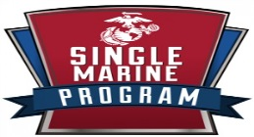

**Bldg. 564 M Street, Camp Lejeune**

**(910) 449-5145**

The primary mission and focus of the Single Marine Program is to enhance the Quality of Life (QOL) and improve the morale and well-being of all Single AND Unaccompanied Marines and Sailors stationed aboard MCB Camp Lejeune.

**Quality of Life**

What are your QOL concerns? We’ll make sure they’re heard. Whether we’re developing initiatives or organizing special events and recreational activities, your thoughts and opinions affect the outcomes.

[**Recreation**](http://smp.mccscherrypoint.com/trips/)

Trips to the beach, UFC fights on big screens at the bar, poker, pool, beach volleyball, and video games are just some of the events we organize and opportunities for fun we provide. We want your leisure time to be full of awesomeness.

**Community Involvement**

We support getting involved with the community on and off base, and we provide opportunities for you to do just that. Learn how to build homes or perfect your skills with Habitat for Humanity, help us keep the beach clean at Rachel Carson Reserve, swap stories with veterans, or volunteer time at the local animal shelter. The experience is a reward in itself, but you can also qualify for recognition under the Military Outstanding Volunteer Service Medal or receive a Letter of Appreciation for your time.

**Ongoing Events at French Creek Recreation Center**

* **Tournaments**

Check our monthly SMP calendar for information on ping pong, giant Jenga, pool, corn hole and various other tournaments. Awesome prizes are awarded to winners. These event is at the French Creek Rec. Center and is for single and unaccompanied Marines and Sailors only.

* **Food, Movies and Games**

Single or unaccompanied Marines and Sailors can drop in to any of the recreation centers around Camp Lejeune for movies, snacks, games and fun with friends during chow or after work.

**CLR 2 HQ Co SMP Representative**

PFC Vasquez, Omar E.

(910) 449-8829



**Resources Continued**

**FOCUS (Families Over Coming Under Stress)** provides resiliency training to military children and families. It teaches practical skills to help families overcome common challenges related to a parent’s military service, to communicate and solve problems effectively, and to successfully set goals together and create a shared family story.

**(910) 450-7268**

[**camplejeune@focusproject.org**](mailto:camplejeune@focusproject.org)

[www.focusproject.org](http://www.focusproject.org)

**SNCO Wives Club Thrift Shop!**

**Location: 1200 Birch St., Camp Lejeune**

**(910) 451-5591**

Monday: 09:00 A.M. – 1:00 P.M., 5:00 P.M. – 8:00 P.M.

Wednesday: 4:00 P.M. – 9:00 P.M.

Friday: 09:00 A.M. – 1:00 P.M.

**Loan Locker**

**Location:** **Russel Marine and Family Programs Center, Bldg 40, Room 105**

**(910)450-8486**

Monday – Friday: 08:00 A.M. – 4:00 P.M.

Waiting on your household goods to arrive? The Loan Locker program is designed to provide the basic essentials for service members waiting on delivery of their household goods. FREE service for 30 days!

The Loan Locker has baby items, kitchen items and other miscellaneous items to help get you through your transition to Camp Lejeune.



**Marine & Family Life Consultant Programs**

Military & Family Life Consultants (MFLC) aboard Camp Lejeune provide short term, situational, problem-solving services to Service Members and their families. Non-medical counseling services are offered in anger management, communication relationship issues, parenting, conflict resolution, deployment stress, coping skills, building resiliency, relocation adjustment, loss & grief and more. Services can be provided on or off military installations to individuals, couples, families or groups. MFLC’s are mandated reporters of child abuse, domestic abuse and duty-to-warn situations, otherwise, all services are confidential and private and NO records are kept.

***Call to schedule an appointment* @ (910) 358-8840**

**DSTRESS: WIN YOUR PERSONAL BATTLES. DSTRESSLINE.COM**

The Marine Corps DSTRESS Line is a 24/7, anonymous phone and chat counseling service with a ‘Marine-to-Marine’ approach.  The call center is staffed with veteran Marines, former FMF Corpsmen, Marine Corps family members, and licensed clinicians with specific training in Marine Corps culture. The DSTRESS Line is a behavioral health counseling service that gives Marines, attached Sailors, and family members a place to call and speak with "one of their own."  It's a place to call and talk anonymously about stress in our lives—from the common everyday stressors to post-traumatic stress to life-threatening crises.   It's non-medical.  DSTRESS Line counselors won't diagnose symptoms, but they will work with callers to help with a way forward.  **1-800-476-7734**

**MILITARY ONESOURCE**

For Marines and their Families!

**1-800-342-9647**

[http://www.militaryonesource.mil](http://www.militaryonesource.com/MOS/MarineCorps.aspx?MRole=Family&Branch=MarineCorps&Component=Active)

• Military Life and Deployment

• Health & Relationships

• Family & Recreation

• Financial & Legal

• Crisis

• And MUCH MORE!

• Career

• Education

• 24/7 Helpline

• Blogs/Troop Tube

• Plan My Move



**Organization**

2ND MLG

CLR 2 ESB

2d Dental Bn

8th ESB

2d Med Bn

Supply Bn

Maint Bn

CLR 25 24ESB

CLR 27

CLB 26

CLB 24

CLB 22 22222ESB

CLB 2

CLB 6

CLB 8

2d TSB



**CLR 2 History**

Combat Logistics Regiment 2 has been enabling the Marine Corps to fight our Nation’s battles for more than 75 years. Although it has held several names and has been remodeled and shaped to adapt to the needs of the Marine Corps, you are joining an illustrious line of warriors who have served in “every clime or place”. Our motto: “Strength and Honor”, is what CLR 2 Marines strive to represent; that is physical, emotional, and mental strength as well as the honor do to what is right – even when no one is looking- are expected from all members at this command.

* Activated 15 February 1941 at San Diego, California, as 2d Service Battalion, 2d Marine Division, Fleet Marine Force
* Deployed during October 1942 to Wellington, New Zealand
* **Participated in the following World War II Campaigns:** Tarawa, Saipan, Tinian, Okinawa
* Redeployed during September 1945 to Nagasaki, Japan
* Redeployed during January 1946 to Sasebo, Japan
* Relocated during July 1946 to Camp Lejeune, North Carolina
* Deactivated 18 November 1947   
    
  **1949-1975**
* Reactivated 19 October 1949 at Camp Lejeune, North Carolina, as 2d Service Battalion, 2d Marine Division, Fleet Marine Force
* Redesignated 15 December 1954 as 2d Service Regiment, 2d Marine Division, Fleet Marine Force, Atlantic
* Redesginated 1 July 1958 as 2d Service Battalion, 2d Marine Division
* Elements participated in the Cuban Missile Crisis, October 1962   
    
  **1976-2006**
* Redesginated 15 April 1976 as Headquarters and Service Battalion, 2d Division Support Group, 2d Marine Division
* Redesignated 1 May 1979 as 2d Landing Support Battalion, 2d Force Service Support Group
* Participated in Operations Desert Shield and Desert Storm, Southwest Asia, 1990-1991
* Participated in humanitarian relief efforts, Central America, 1998-1999
* Redesignated 30 March 2000 as 2d Transportation Support Battalion, 2d Force Service Support Group
* Elements participated in Operation Iraqi Freedom, Iraq, March-November 2003, August 2004-February 2005 and March 2006-October 2007
* Redesignated 18 May 2006 as Combat Logistics Regiment 2, and assigned to 2d Marine Logistics Group

**2007- Present**

* As part of 2d Marine Logistics Group, our Marines and sailors have deployed as units and individuals in support of numerous exercises, Special Purpose Marine Air-Ground Task Forces, and combat operations across the globe.

**Welcome Aboard Questionnaire**



Name: __________________________________ Rank: ____________ MOS: ____________

DOR: __________________ EAS: ___________________ “B” Billet: _____________________

Previous Command: ____________________________________

Home Town & State: ________________________________________

Rank Appropriate PME: (Fill out only CURRENT rank data)

Lance Corporal: EMPE3000AA Date: _______________ LCpl Seminar Date: _________________

Corporal: EMPE4000AA Date: _______________ Cpl Course Date: _______________

Sergeant: EMPE5000AA Date: _______________ Sgt Course Date: _________________

Staff Sergeant: EMPE6000AA Date: _______________ Career Course Date: ________________

Gunnery Sergeant: EMPE7000AA Date: _______________ Advance Course Date: ______________

Marital Status: M / S

If married, do you have a family care plan: Y / N

Do you have dependents? Y / N

Have you deployed recently and where have you deployed?

**_____________________________________________________________________________________**

What billet(s) have you held?

**_____________________________________________________________________________________**

Do you have any hobbies or skills?

**_____________________________________________________________________________________**

PVT – Cpl:

Bring a copy of your Transfer Pro/Con markings.

Sgt & SNCO:

Print a copy of your MBS last copy of your FitRep (if possible).

**RETURN TO THE COMPANY FIRST SERGEANT – UPON CHECK-IN**